AWS Steps

Sign up for AWS Fraud Detector Account
Go here, https://aws.amazon.com/fraud-detector/
Follow ‘Get Started with Amazon Fraud Detector’ steps.

Prerequisites
Historic data with customer, order, billing, shipping and fraud indicator. There are two special fields that are require by AWS: EVENT_TIMESTAMP and EVENT_LABEL.

You need at least 10,000 records and at least 400 need to be fraud.
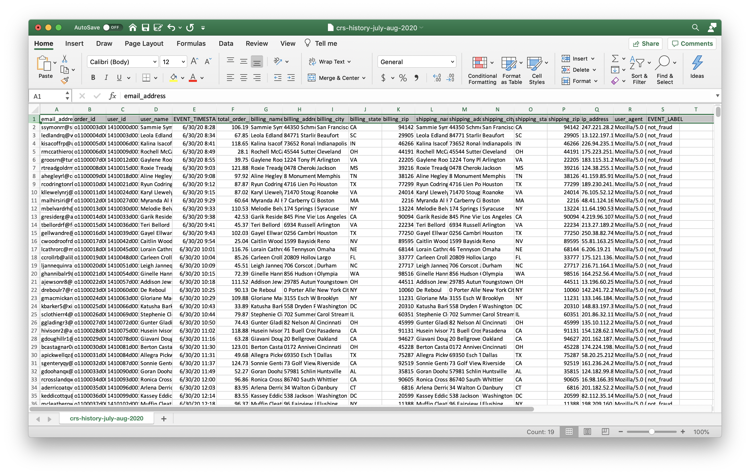

Set up Fraud Detector Resources
You will need to set up resources in AWS Fraud Detector console.

Entities
You will need customer entity in order to create create_order event.
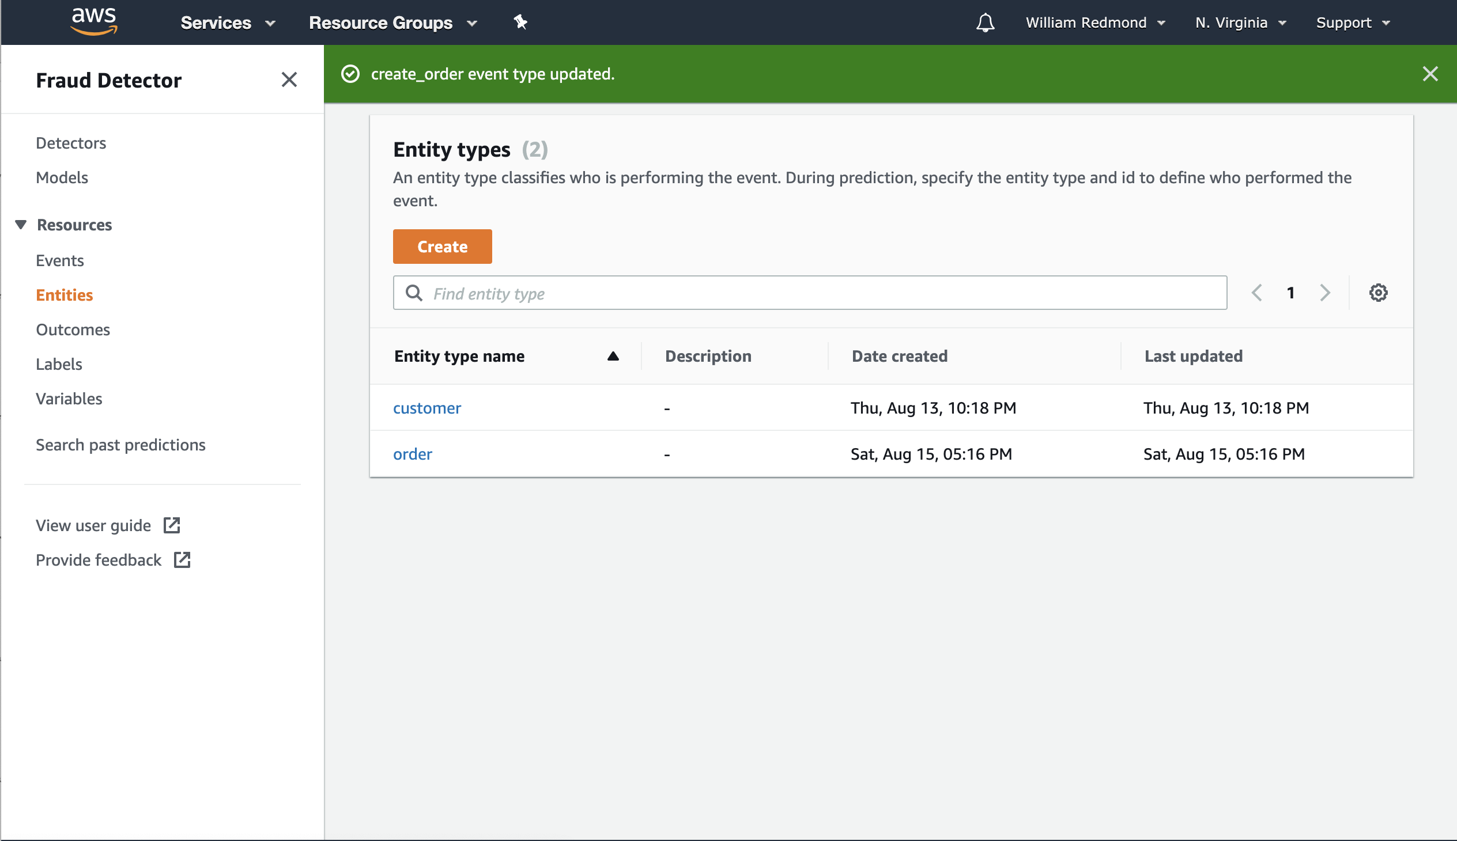

Events
You will need create_order event.
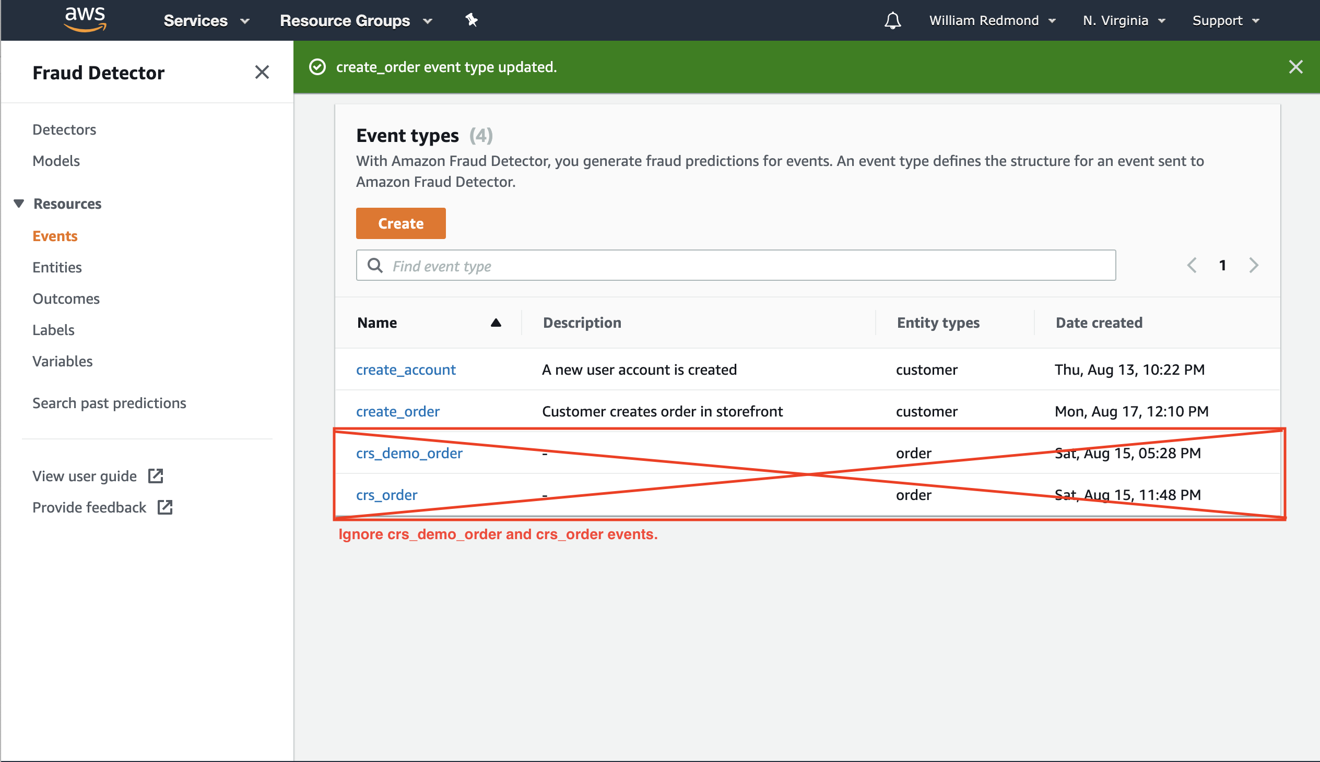

Outcomes
You will need block_order and cancel_order entities
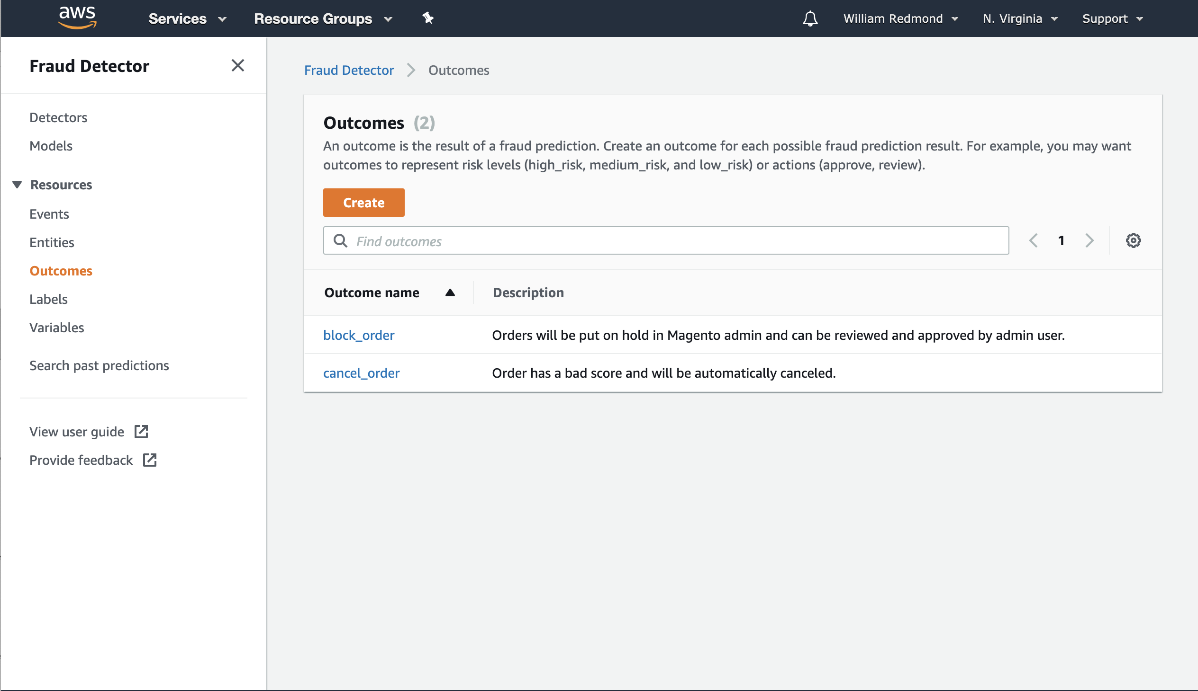

Labels
You will need fraud and not_fraud lables.

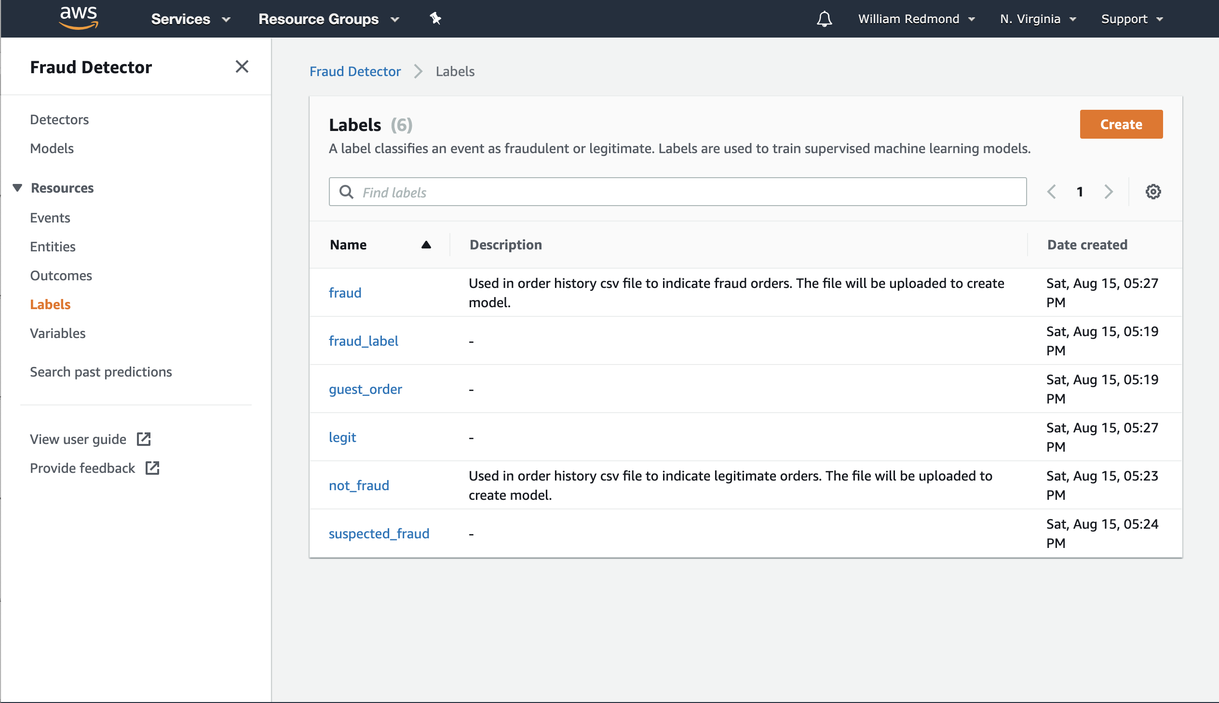

Variables
We will let variables be created when we upload order data and train the model.

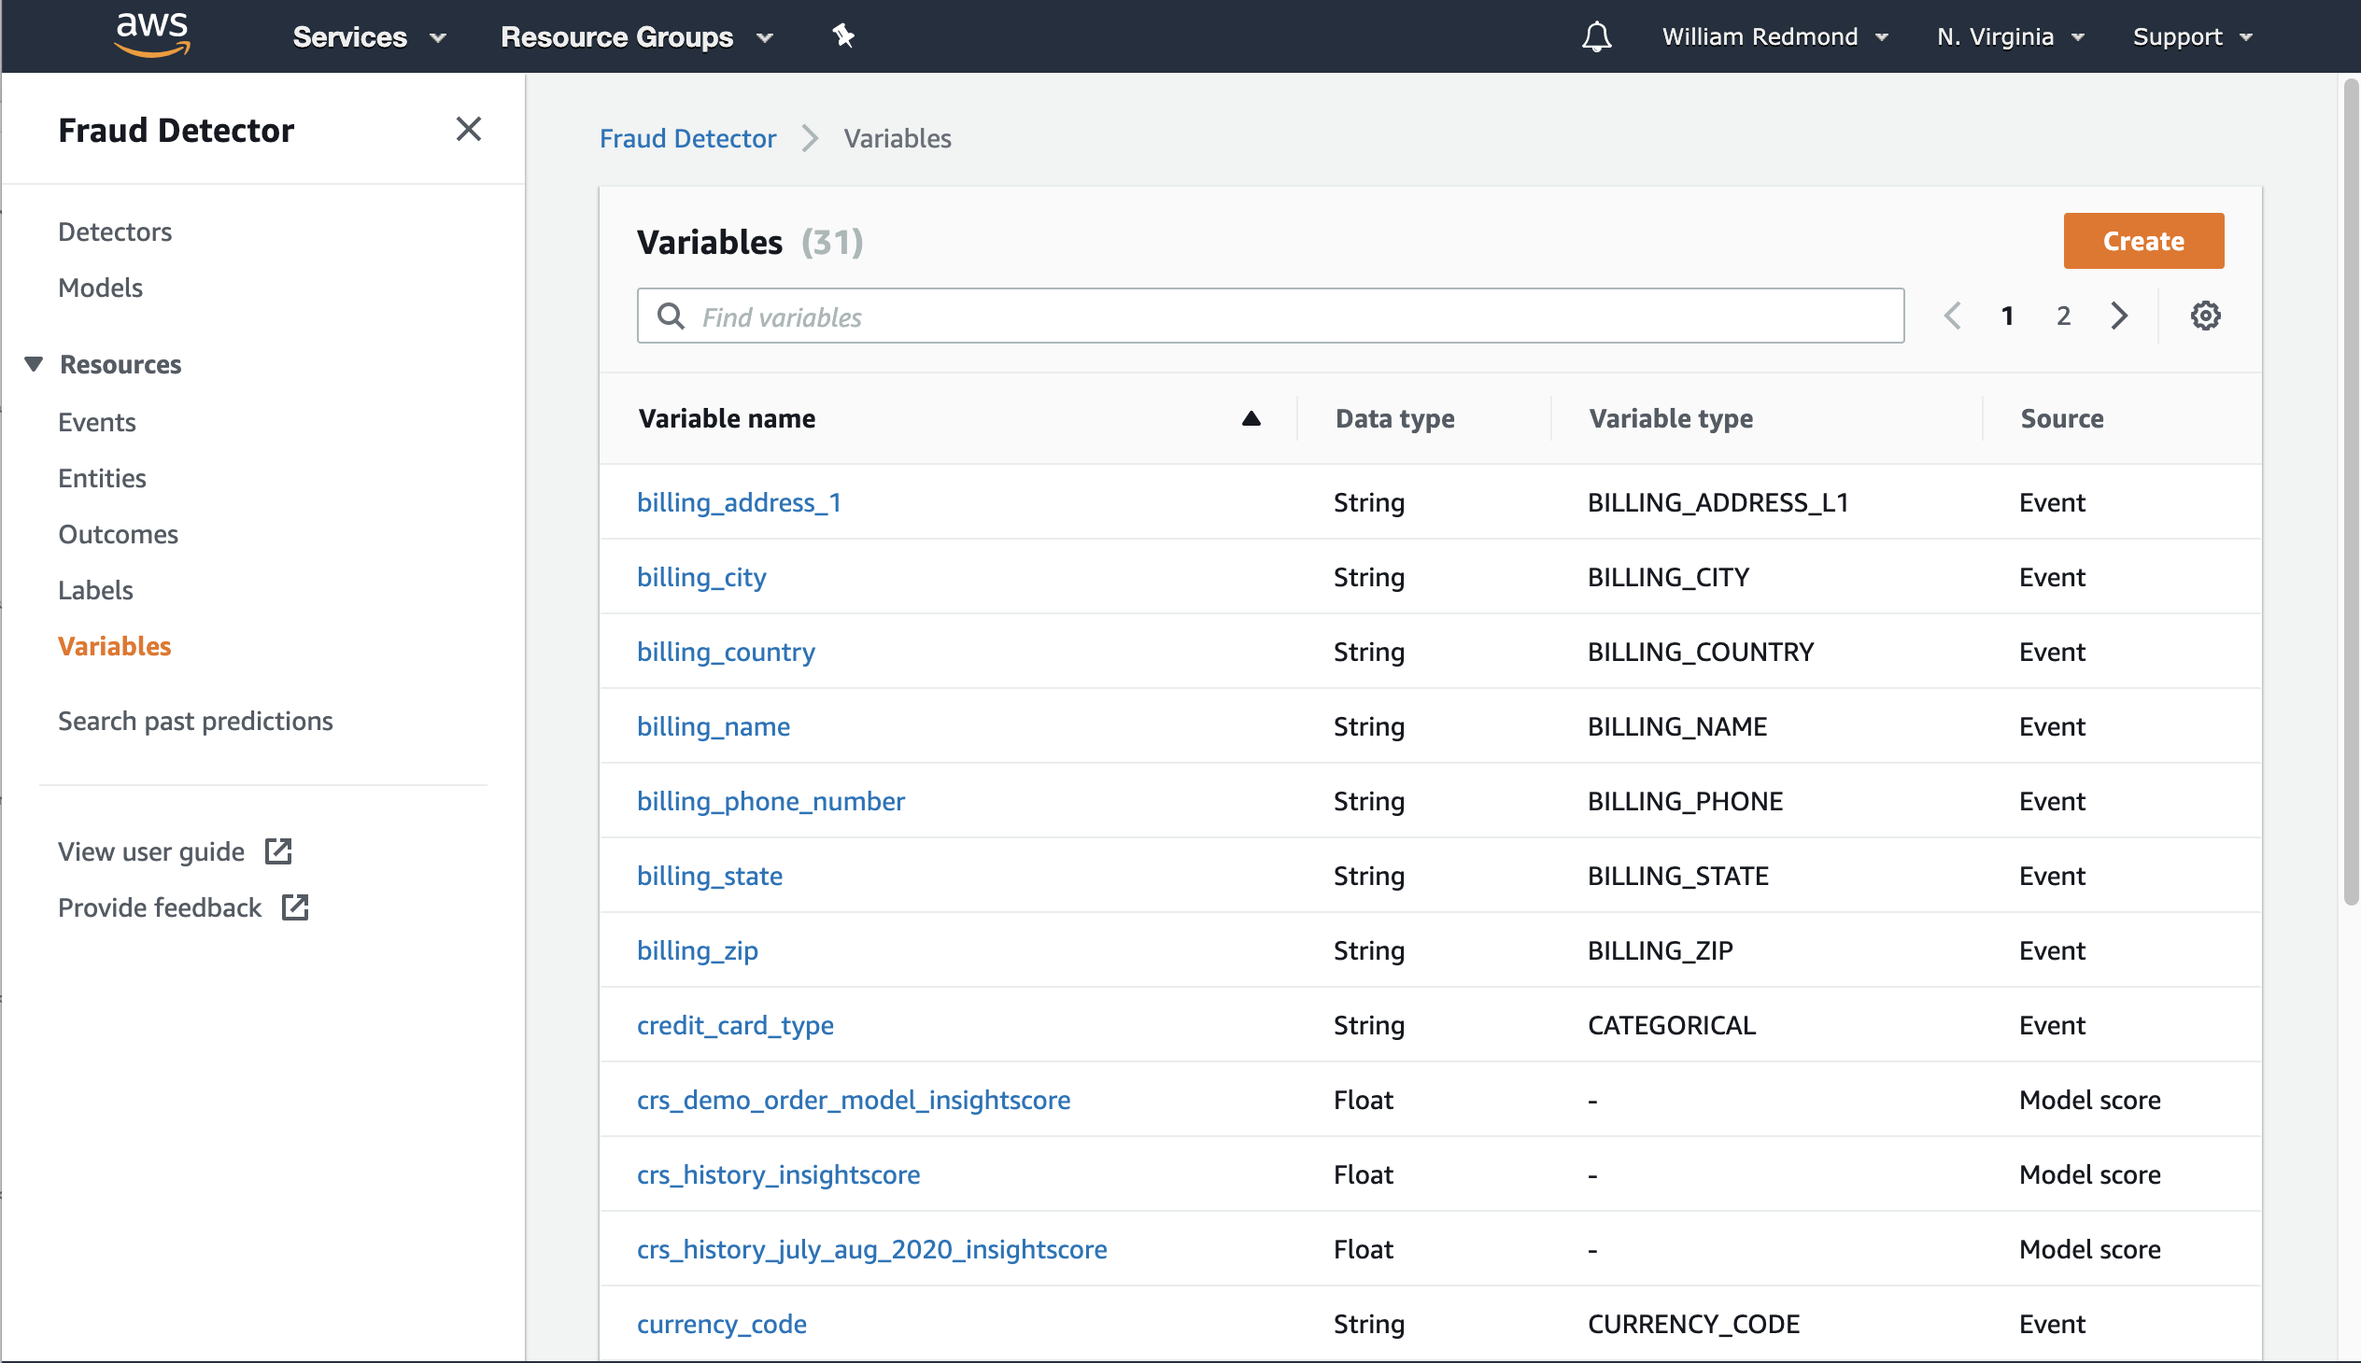

Create a Model
In order to get and fraud score from Amazon you need to upload and train a model. You need at least 10,000 records and at least 400 need to be fraud. You can upload the data in a csv file to an AWS S3 bucket.

Reference doc: https://docs.aws.amazon.com/frauddetector/latest/ug/create-model.html

The model type should be ‘Online Fraud Insights’ and the Event type should be create_order. You upload the data from the S23 bucket, train the model, and deploy the model. The model is available to be used by a detector.

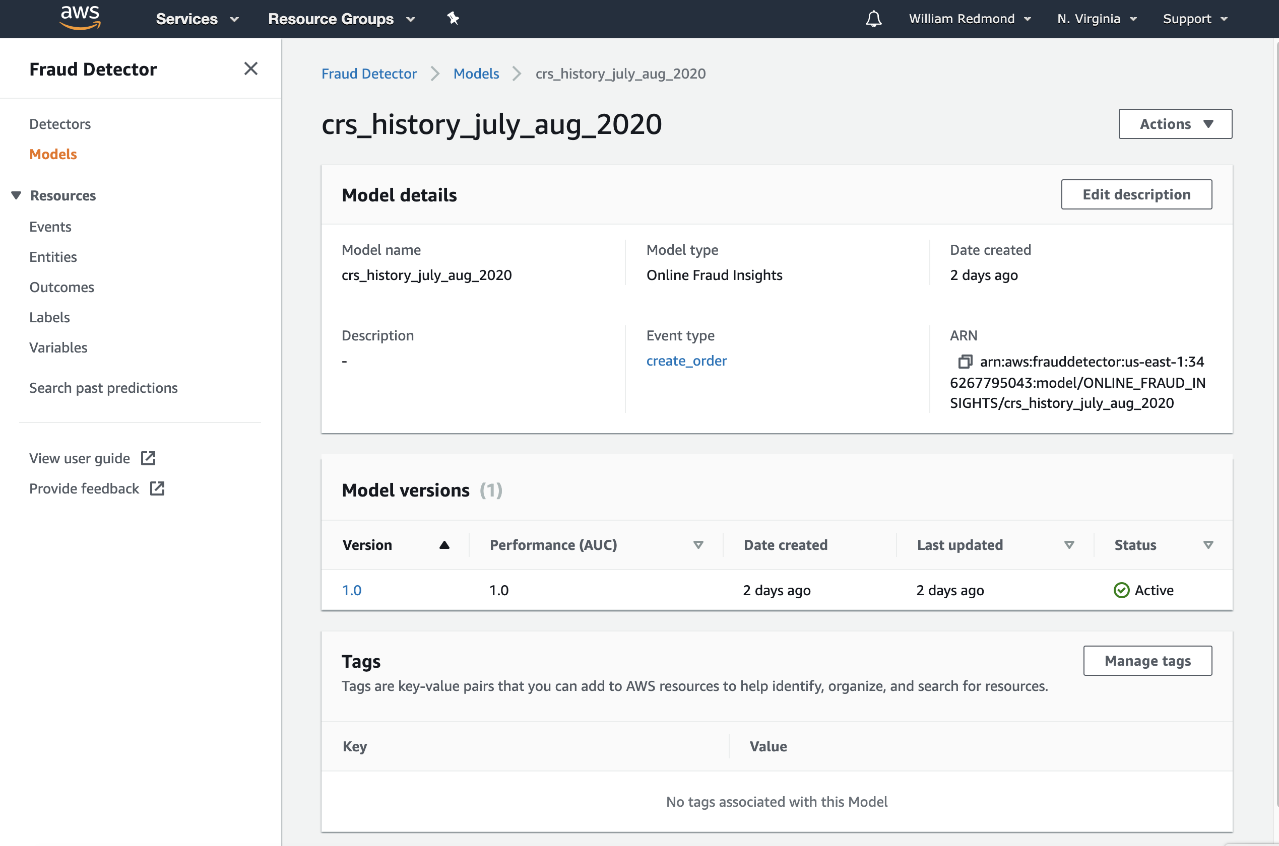

Create a Detector
You detector will use the same event type and your model, create_order. Addin a model to a detector is optional, but if you want to receive an be ‘Online Fraud Insights’ score you will need a model.
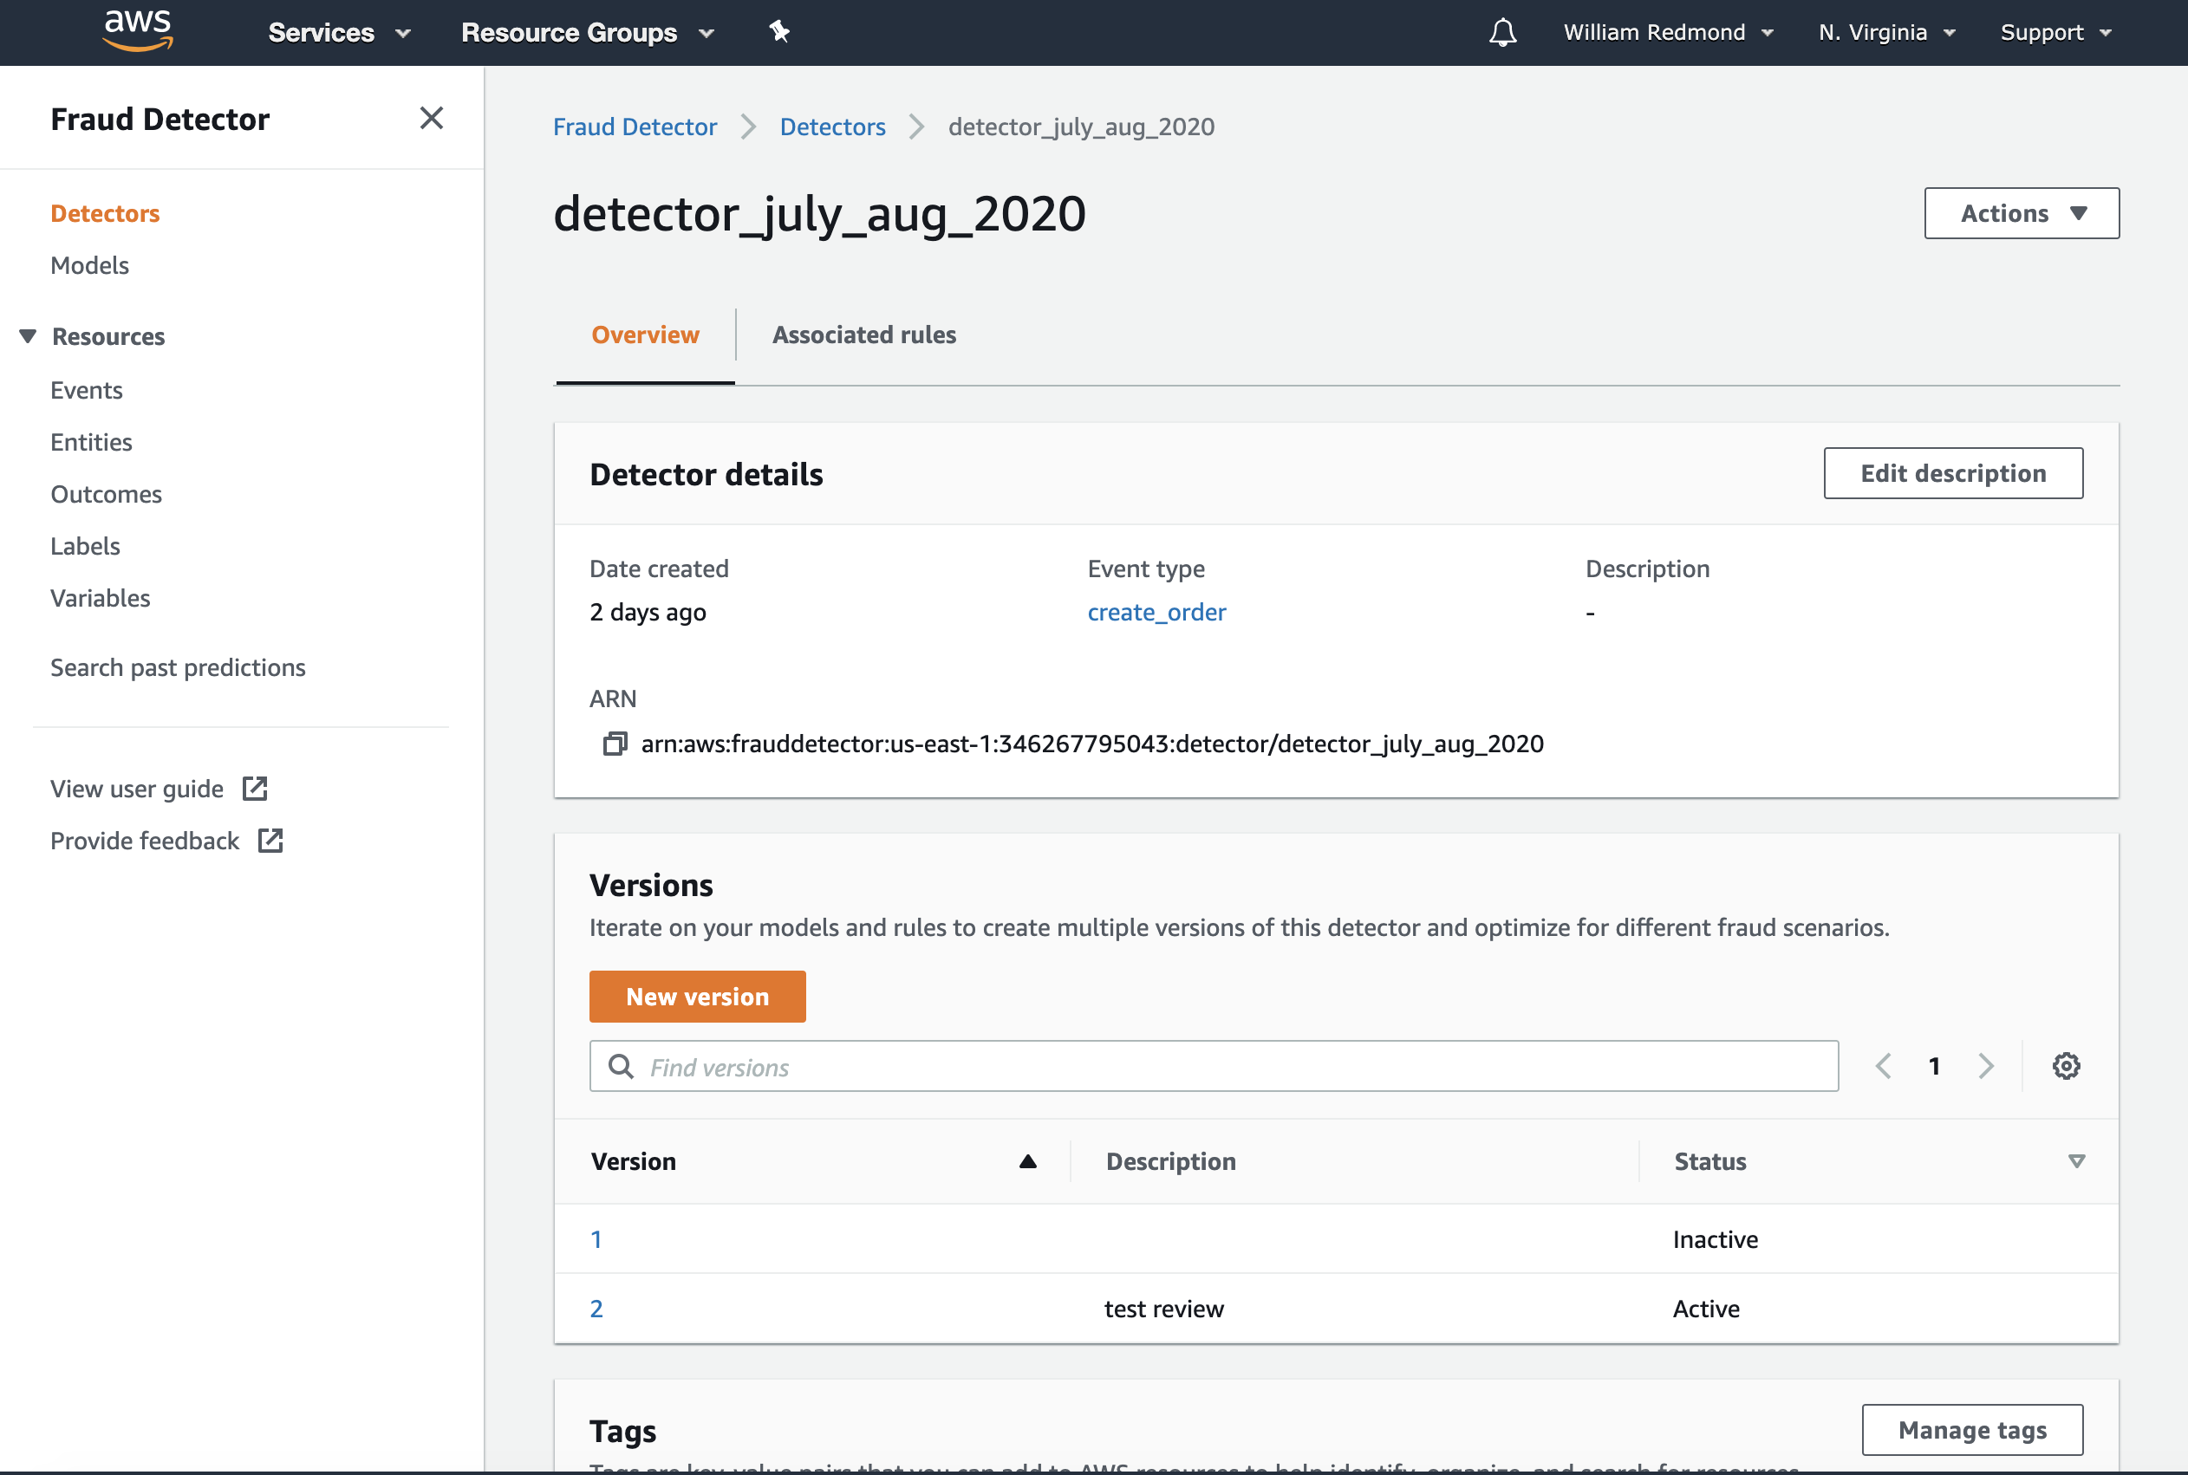

Add rules to the detector. The rules are evaluated, and an outcome is returned to the Magento integration.
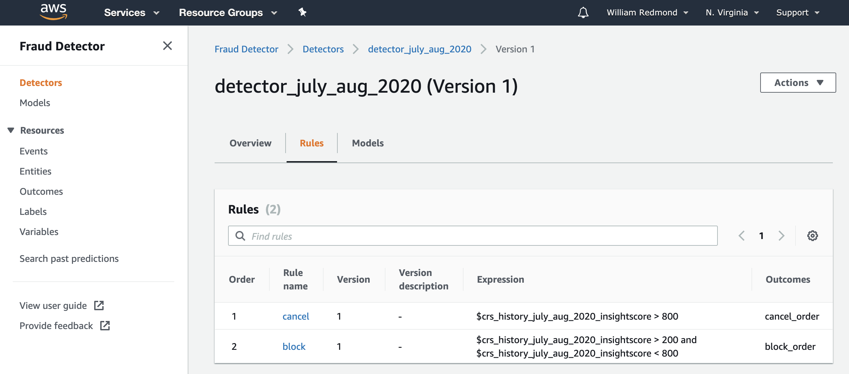

Magento Configuration

In Magento admin go to Stores > Configuration > Sales > Fraud Protection and expand the Transom – Amazon Fraud Protection – API Configuration section.

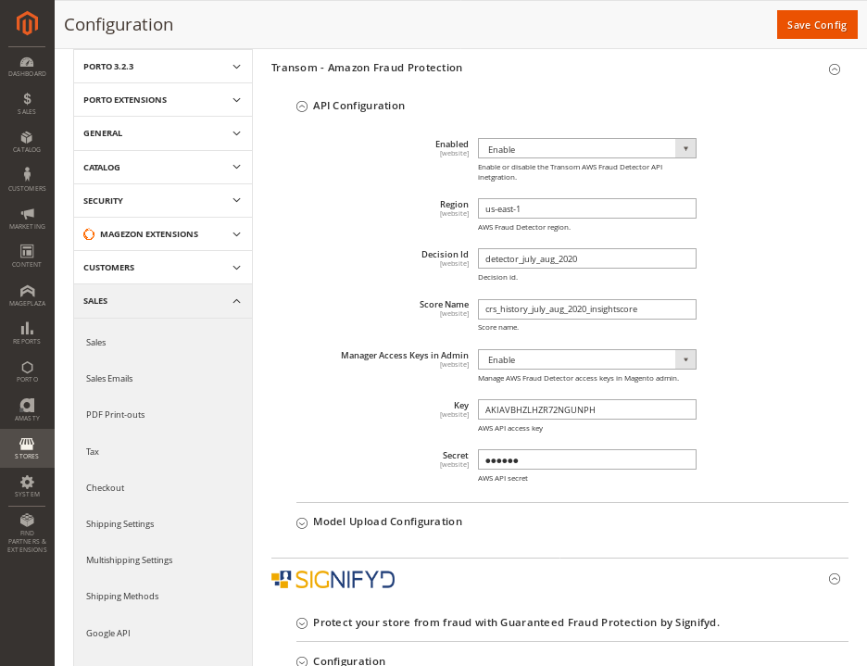

Magento Order Management

